Metal Box

Polymer Box

Panel Protector / Hardwire / M200-480 3D 2nd Edition

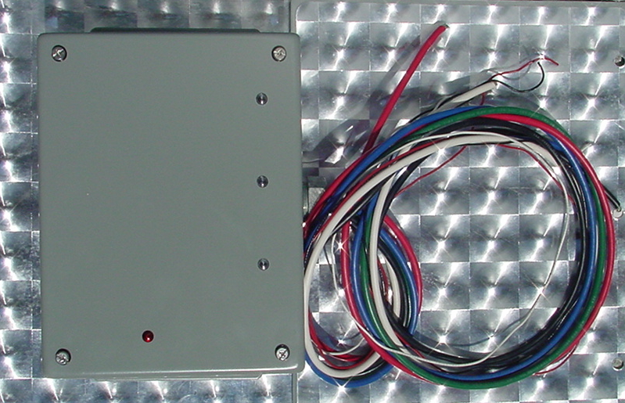
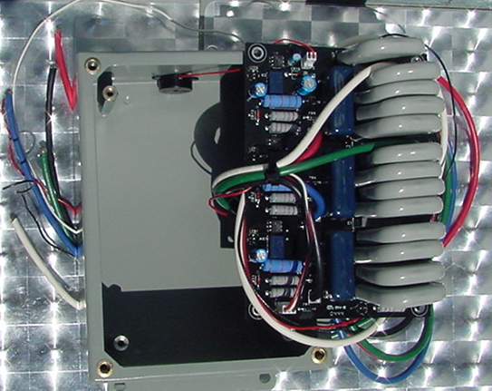
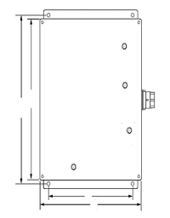

Specifications - Operating: Dry Contacts
8 3/4
8
Maximum Operating Voltage: 480 Volts AC
Typical Leakage Current: <5µ amps
Operation Temperature: - 40 to +85°C
Connectors: Hardwired
Lines Protected: L-L, L-G,
Installation Configuration: Parallel
4
6 1/4

Specifications - Electronic:
Maximum Surge Current (8x20µs): 600,000A total, 200KA per Phase
Maximum Surge Voltage (1.2x50µs): 10,000 Volts
Capacitance: <2,000 pf
Clamping Voltage: 510 Volts RMS
Clamping Response Time: <5 nanoseconds
Current: Non-Load Bearing
Voltage: Voltage Sensitive
Design: (3) Thermally Fused Hybrid
Operation Indicators & Audible Alarm (4) Light Emitting Diode (LED)
Power Dissipation (8x20µs): 102,000,000 Volts Amps
Energy Dissipation: 7600 Joules
UL 1449: 1449 Second Edition
UL and CUL Approved: United States / Canada
Dimension: Depth 3 1/2"
Length 8 3/4"(including tabs)
Width 6 1/4"
Weight: Approximately 7.5 lbs Nema 12 Box

Pass Voltage Tested to ANSI/IEEE B3 Impulse: (L-L)1800VoltsPeak(L-G)1000V PK

Stormin surge suppressors have a Ten Year Product Warranty. Please see warranty statement for complete product warranty information.

Page 14
Click here for Index Click here for Page 13 Click here for Page 15

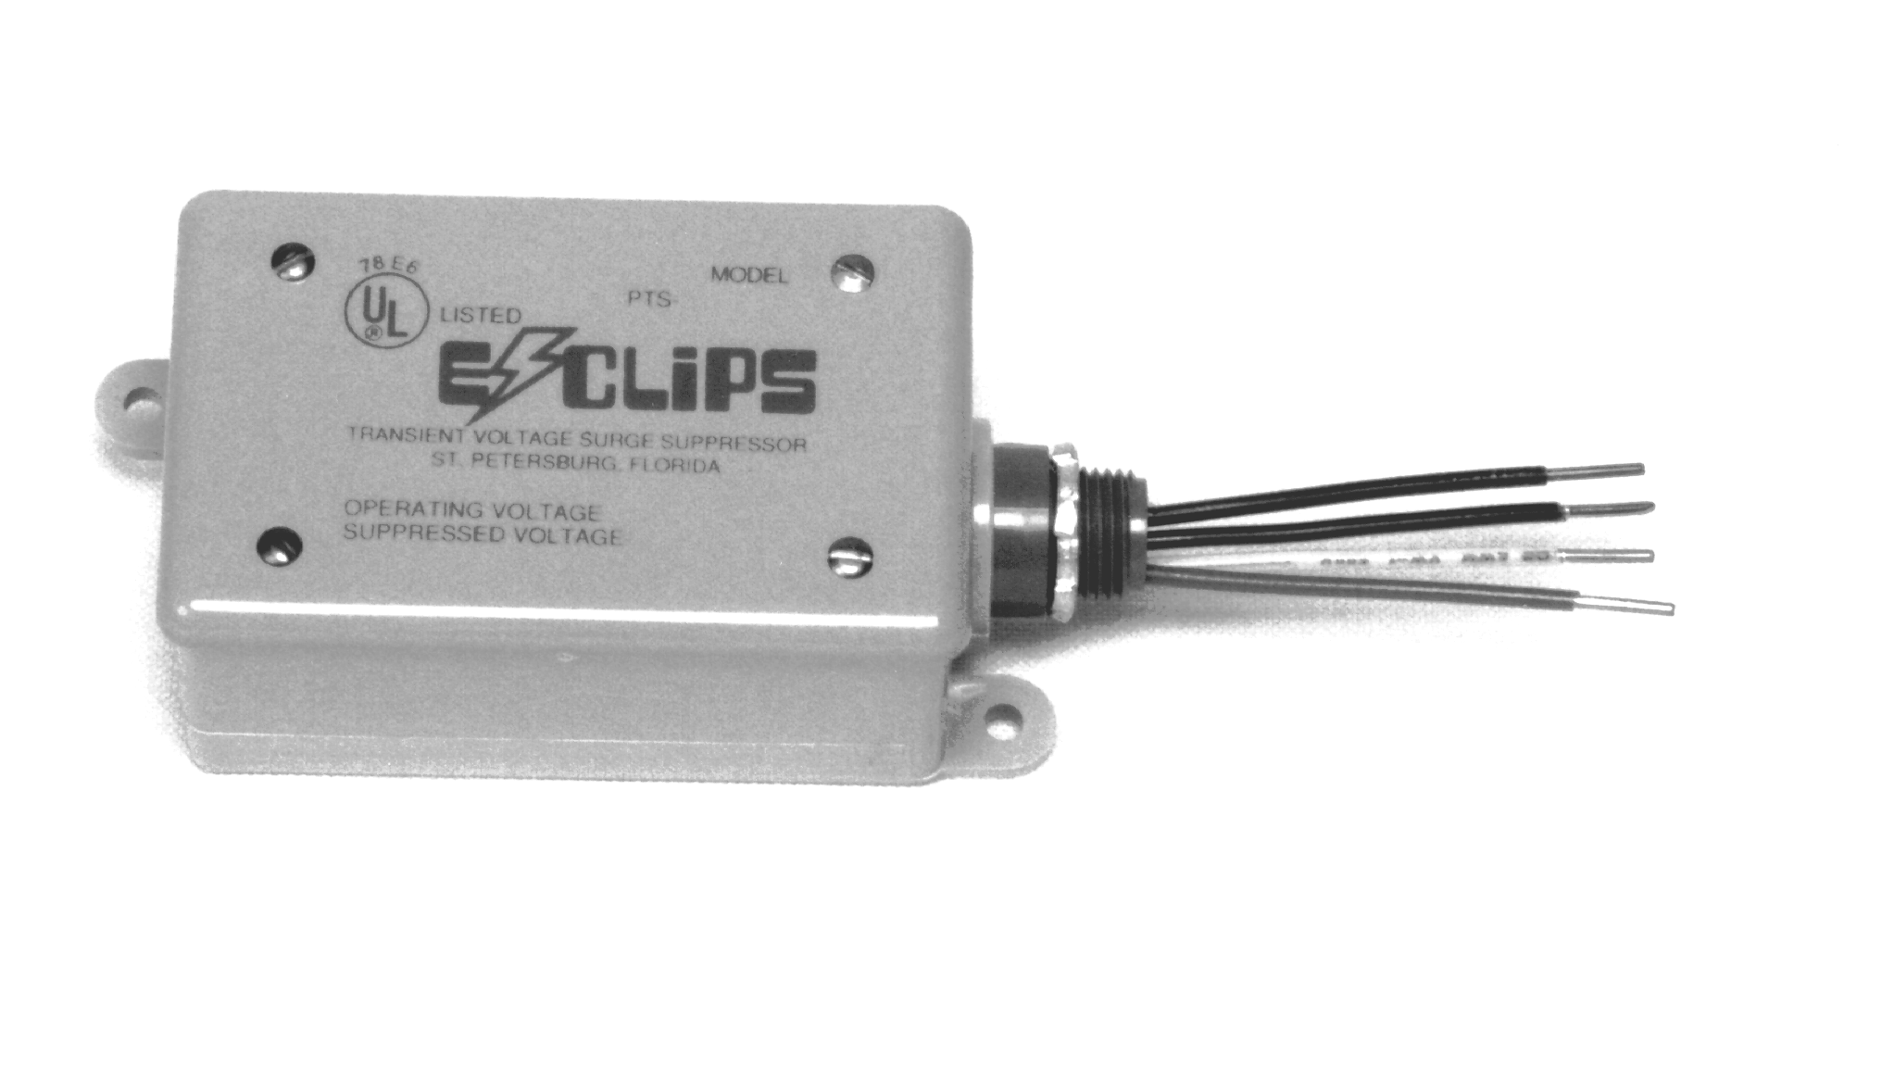
Metal Box

Polymer Box

Panel Protector / Hardwire / 480 3D/2nd Edition
(Cepter/Carlon Box)

Specifications - Operating:

Maximum Operating Voltage: 480 Volts AC
Typical Leakage Current: <5µ amps
Operation Temperature: - 0 to +85°C
Connectors: Hardwired
Lines Protected: L-L, L-G
Installation Configuration: Parallel

Specifications - Electronic:
Maximum Surge Current (8x20µs): 300,000 Amps Total

Maximum Surge Voltage (1.2x50µs): 10,000 Volts
Capacitance: <4,000 pf
Clamping Voltage: 510 Volts RMS
Clamping Response Time: <5 nanoseconds
Current: Non Load Bearing
Voltage: Voltage Sensitive
Design: Hybrid
Power Dissipation (8x20µs): 39,000,000 Volt Amps
Energy Dissipation: 3030 Joules
UL 1449: 1449 Second Edition
UL Recognized Component:
UL 514 Enclosure (Marine/Weather Proof):
USL and CNL Approved: United States / Canada
Dimension: Depth 2.50"
Width 4.750"
Length 5.800"
Tabs ½", Neck ½"
Weight: Approximately 2 lbs.

Pass Voltage Tested to ANSI/IEEE B3 Impulse: (L-L) 1260 Volts Peak, L-G 870 Volts Peak.

E-Clips surge suppressors have a Ten Year Product Warranty. Please see warranty statement for complete product warranty information.

